**Lab ASSIGNMENT 4**

1. Write a program using Array of Objects to display area of multiple rectangles.

Code:

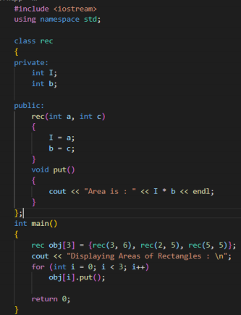

Output:

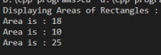

2. Write a program to create a class that contain the following properties of Employees. All the properties should be private and any access to input and display employee data should be through public functions. Input the number of employees to maintain from user and initialize employees the array of objects.

|  |  |  |
| --- | --- | --- |
| private: | Employee Id | int |
| Employee Name | char array |
| Employee Age | int |
| Employee Salary | Int |
| public: | inputInfo() | void (return type) |
| displayInfo | void (return type) |

Code:

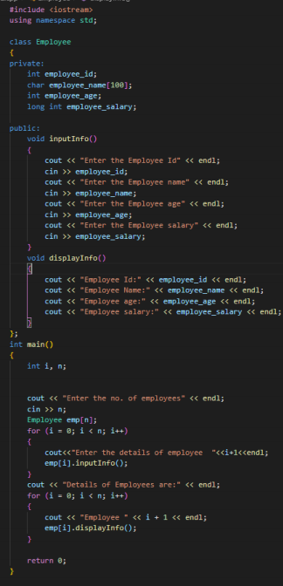Output:

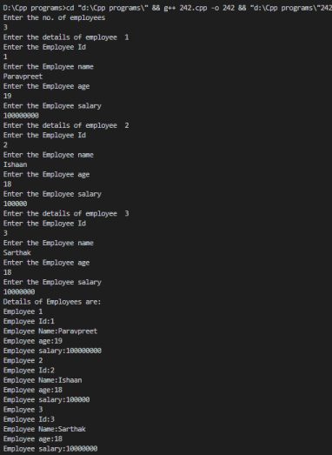3. Write a C++ Program to demonstrate the following uses of *this* pointer: ∙ Returning Object

Code:

Output:

∙ Distinguishing Data Members Code:

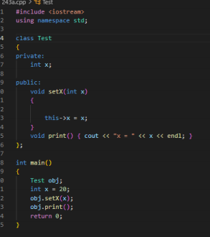

Output:



4. Write a C++ program to create dynamic array of integers using new and find the smallest element in the array.

Code:

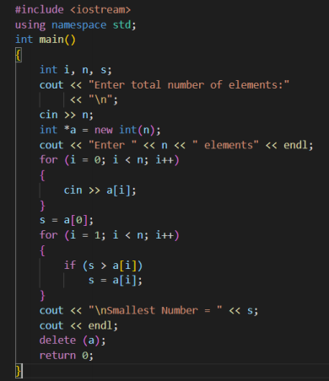

Output:

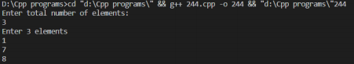

5. Modify program 2 to demonstrate the use of dynamic constructor using *new* keyword.

Code:

Output:

